**Members**

Lisa Chen

**File Listing**

* **searchAgents.py** 
  + File defining search agents and search problems
  + Implemented foodHeuristic, findPathToClosestDot(), and AnyFoodSearchProblem’s isGoalState()

**What I’ve learned**

I tried to reuse what I used in Problem 6’s Corner Problem for Problem 7, but unfortunately the heuristic wasn’t consistent. I struggled and tried multiple tweaks and ended up trying mazeDistance() instead of using manhattan distance or euclidean distance. It gave me a lot better node estimate and was consistent (best result with returning max versus average or summing all of the distances from closest food), but I found it to be very slow. To improve on it and using returning the max distance, I instead calculated manhattan distance to all the food points. Then, I chose the farthest 4 points (or less if there were less food points than 4) and calculated the maze distance; this gave a little bit more node exploration but cut the calculation time in half. For Question 8, it was relatively easy to implement with only 1 line of code for findPathToClosestDot() and isGoalState()

Question 7: Eating All the Dots: Pacman Terminal Prints

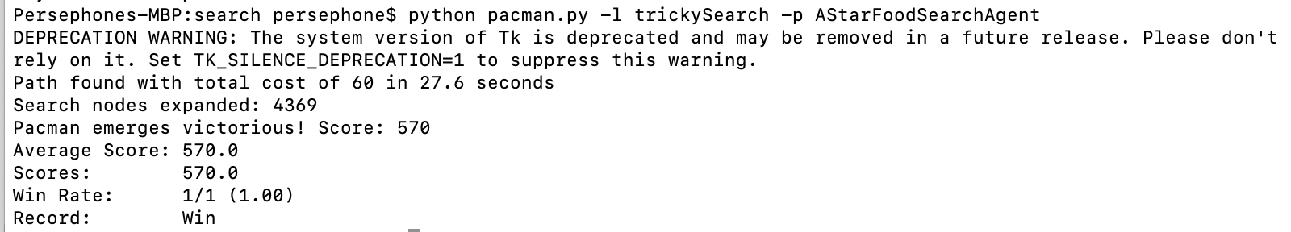

Autograder Question 7

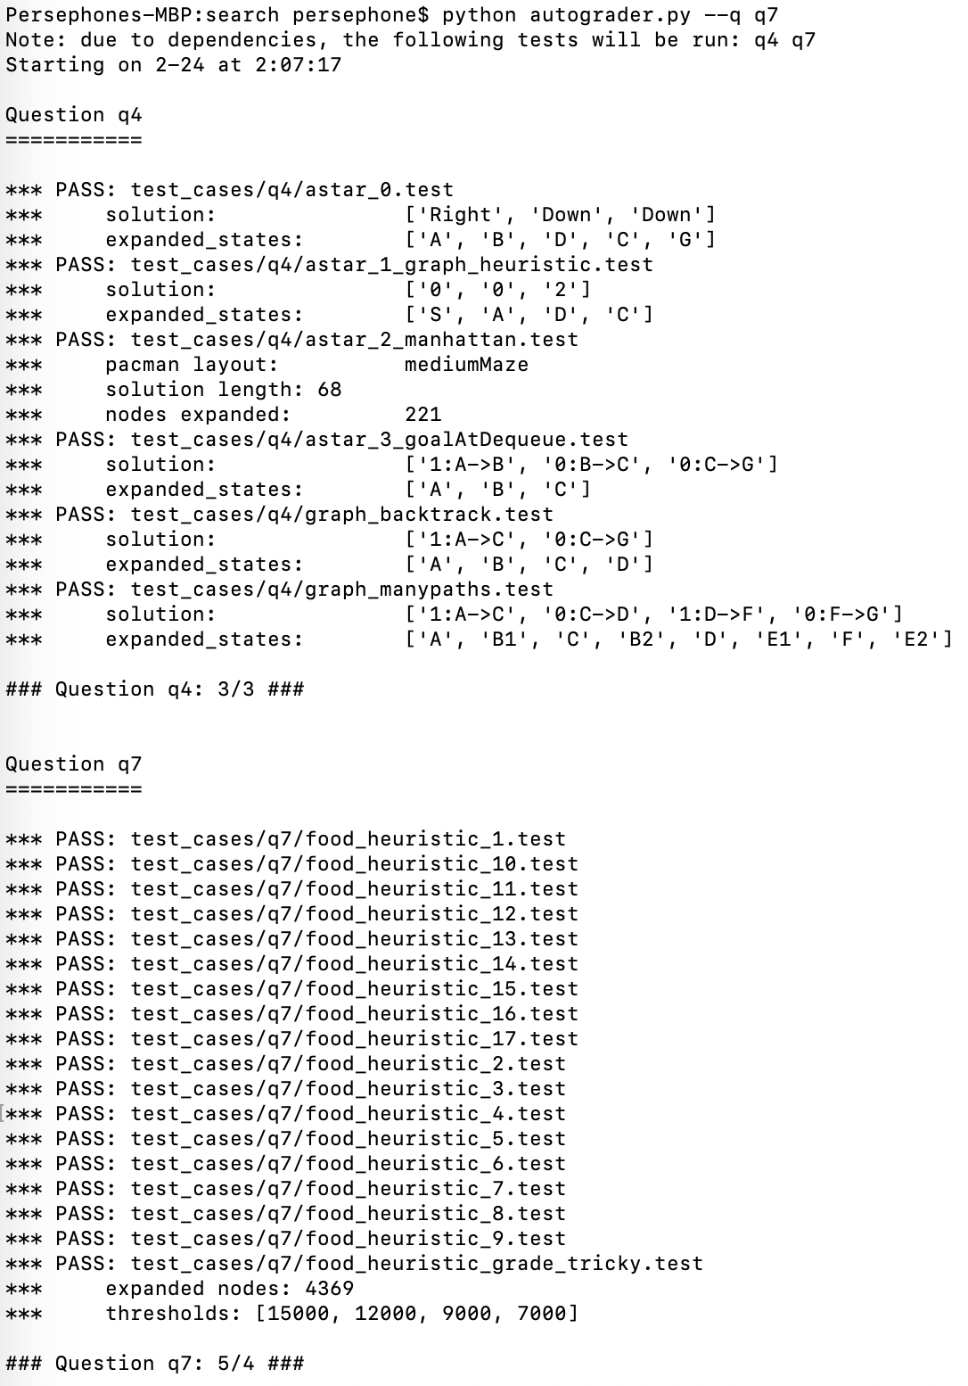

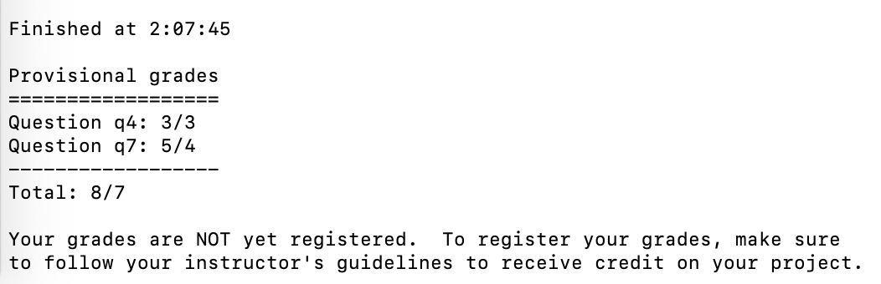

Question 8: Suboptimal Search: Pacman Terminal Prints

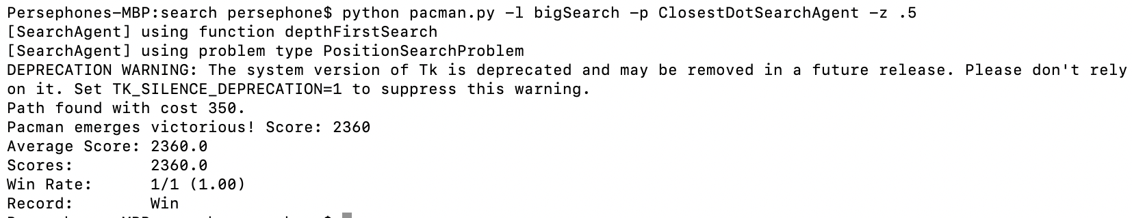

Autograder Question 8

